Table S1 Effects of different N supplies and temperatures on the CO₂ compensation point in the absence of respiration (Γ*) and mitochondrial respiration rate in the light (R_{d}).
N | Temp.  (ºC) | Γ*  (μmol mol⁻¹) | R_{d}  (μmol m⁻² s⁻¹)
LN | 28 | 43.8±1.06b | 2.80±0.71a
 | 40 | 53.1±6.70a | 2.10±0.48ab
HN | 28 | 44.4±1.48b | 1.53±0.38b
 | 40 | 57.3±2.58a | 2.19±0.16ab
Notes: Data were presented as means ± SD of three replications; Data followed by different letters are significant at P < 0.05 level.

Table S2 Effects of different N supplies on the leaf N and Rubisco content of the newest fully expanded leaves.
Treatments | N  (g m⁻²) | Rubisco  (g m⁻²)
LN | 0.974±0.055b | 3.092±0.448b
HN | 1.384±0.142a | 4.806±0.078a
Notes: Data were presented as means ± SD of three replications; Data followed by different letters are significant at P < 0.05 level.

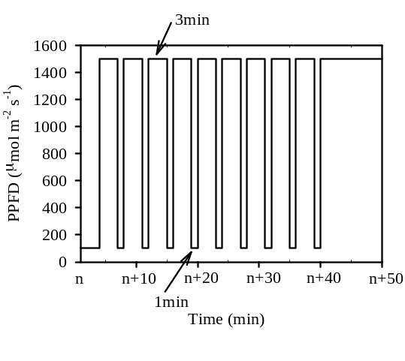
Fig. S1 The procedures of the photosynthetic induction process measurement under periodic high light.

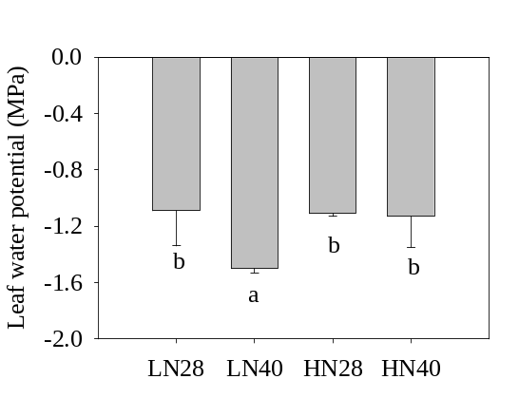
Fig. S2 Effects of different N supplies and temperatures on the leaf water potential (Ψ_{leaf}), which was measured after the measurement of leaf hydraulic conductance (K_{leaf}).

